CSS Report

# Imagemap –

The imagemap was one difficult component for me to get right in this website, I had many problems trying to get it to work, from it changing the whole page to the textboxes having one word per line and the spacing between each line being a lot larger than what it was supposed to be. The code for the imagemap can be found in the *designs* page in the head part of the html file.

# Text styles –

In the main css of the site, the text styling was altered a few different ways. I changed the styling of the text with the elements;

* Font-family
* Font-size
* Colour
* Font-weight
* Padding
* Animation (heading tag in the index page)

# Navigation –

The navigation bar was the other component of the site that has difficult to make, probably because I had to change it to a drop down menu instead of the menu system that I used for my Cert 3 last year. When I has changing the navigation bar, I had to make another css sheet and link it to my website. While I was changing the navigation bar, one of the components that I had changed, screwed up imagemap which cause a lot of wasted time trying to fix that up again.

# Layout –

For the layout of the site, I used the *float* element on divs that needed to be placed next to other divs (i.e. sidebar and headers). This was achieved by adding the element *float-right* and *float-left.*

I made the site responsive by using percentages instead of pixels for the widths of divs and added the media queries to determine what the site looked like on different screen sizes. There were some components in the site that were made hidden for tablet and mobile phone screens (imagemap and the sidebar), which were unconventional for the touch screen as it would either have a hover element to it or would have made the site too squished and would have been difficult to read.

# Other –

* + Media queries –
    - For the media queries, I added the code *@media (min-width: 481px) and (max-width: 801px)* to the end of the main css for a computer screen, I added two media queries to the site, one for a tablet screen and one for a mobile phone screen.
  + Animations –
    - The animation component in the website is for the main header in the home or index page. I added the animation by adding another css sheet for the animation, I then added a class to my h3 tags and altered the elements until I got the desired result.
  + Child and direct descendant selectors –
    - The child and direct descendant selectors component in the website is in a table in the *designs* page, I changed what happens here by adding the following code ;

.fit td:nth-child(1) {  
animation-name: bounce;   
animation-duration: 2s;  
}

* + Z-index layering –
    - The z-index layering component of this website is in the *designs* page in the imagemap. These are the ‘?’ on the imagemap.
  + Transparency –
    - The transparency component in the website is in the footer. I changed the opacity of the div by adding the element *opacity* to the main css sheet.
  + Element sizing for fluid design –
    - This element of the website is in the main css and it changes the size of the images and divs and what not so that the site is responsive for all screen sizes, well in theory at least. This took me a while to finalise because I tested each different component on each page multiple times with each change that I had made to ensure that the site worked like it is supposed to.

# Testing Comments

While testing in different browsers, I had most of the sidebars a different length to the main content area, I fixed this issue by changing the minimum height for both the sidebars and the main content divs.

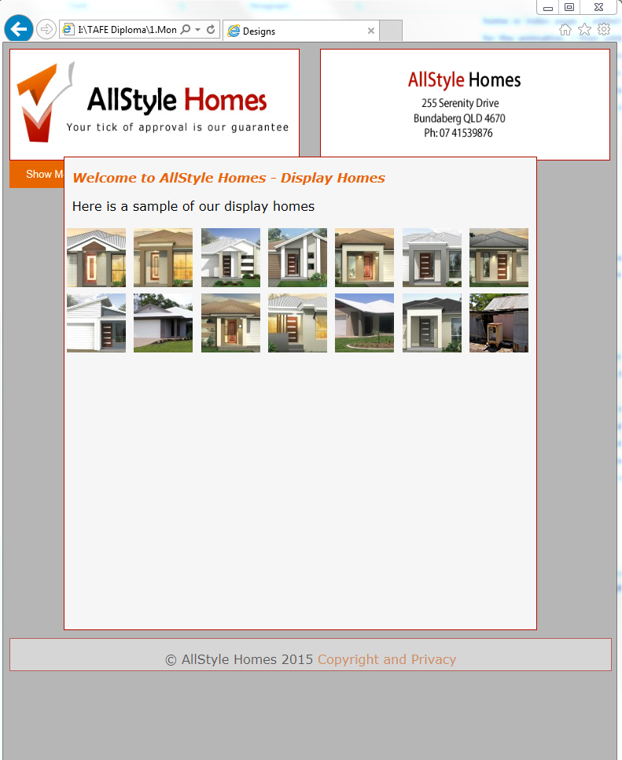

This happens at a certain screen width in IE, Chrome and Firefox, when I make the screen smaller it seems to fix itself. To fix this issue I added the property *clear:both.*